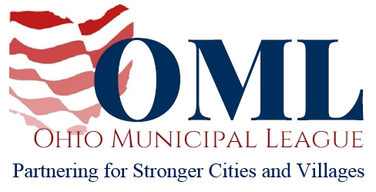

WRITTEN TESTIMONY TO THE HOUSE STATE AND LOCAL GOVERNMENT COMMITTEE

PROPONENT TESTIMONY

HB 264

October 2, 2019

Chair Wiggam, Vice Chair Ginter, Ranking Member Kelly, and members of the House State and Local Government Committee, thank you for the opportunity to write in support of HB 264.
HB 264 could result in substantial savings for many municipalities by allowing the Ohio Water Development Authority (OWDA) to refinance loans for certain public water and waste water infrastructure projects.
OWDA is currently restricted to only making loans and grants to local governments for acquiring or constructing water and wastewater facilities. Because they are not authorized to refinance those loans, the city is unable to save taxpayer dollars by refinancing at a lower interest rate in the event those rates drop.
Municipalities should be able to use all available tools at their disposal in order to be good stewards of the taxpayer’s money. HB 264 makes a common-sense adjustment to current law to give them another potential path towards saving money and reducing the financial burden on their citizens.
It has become increasingly important for municipalities to find ways to budget and save revenue. Over the years, municipalities have borne repeated blows to critical revenue sources such as steep cuts to the Local Government Fund, the elimination of the estate tax, the centralized collection of municipal net profit income taxes and other state preemptions that impact municipal budgets. More action is needed on the part of the state to create revenue-saving mechanisms such as the one created in HB 264.

We thank Rep. O’Brien and Rep. Wilkin for recognizing the need for this bill and for working to enable Ohio municipalities to continue delivering quality services to their community.
Thank you for your consideration, and we urge for your favorable passage of this bill.
Sincerely,
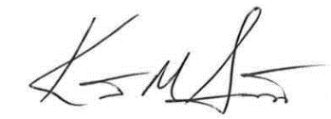

Kent Scarrett
Executive Director
Ohio Municipal League

