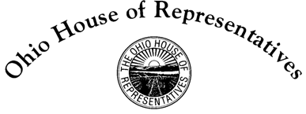

**Tom Brinkman, Jr.**

State Representative

27th House District

Chair Green, Vice Chair McClain, Ranking Member Sheehy, and members of the House Transportation Committee, thank you for the opportunity to testify on behalf of House Bill 147. This legislation aims to address the manner in which the Ohio Bureau of Motor Vehicles releases photos.

In the past news media could obtain your photo for release to the viewing public in two ways:

1. A photo provided by you or your family whose use was authorized, or
2. A criminal mug shot

Over the last few years law enforcement and other state agencies has been releasing driver’s license photos without any indication on said photos under what circumstances the photo was obtained. Because these photos are released without any identifying mark, and the “mugshot” appearance of many identification photos, the public is lead to believe that the citizen has in fact been “in trouble” and has a criminal history.

The explosion of internet sites rushing headlines to the public in order to drive up clicks has sent the release of photos into overdrive.

In order to protect the reputation of the law abiding citizens of Ohio and the manner in which they are presented to the public, the bill intends to have state agencies embed a “watermark” of their agency logo on every photo they take at the time they take it. There fore there can be no confusion among law abiding citizens and damage to their reputations should the photos be released.

The Bureau of Motor Vehicles is the largest photographer of Ohioans and my preliminary discussions with the new Register, Charlie Norman, have been positive. Certainly we welcome their input because the new REAL ID compliant driver’s license poses some challenges. But Mr. Norman is working with staff to make sure passage of HB 147 would result in nominal cost; I wouldn’t have it any other way.

Thank you again for the opportunity to testify to this body, and I look forward to any questions you might have.