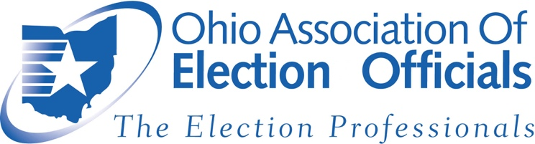

Proponent Testimony
Senate Bill 52

Chairman Green, Vice Chair-McClain and Ranking Member Sheehy:

Thank you for the opportunity to submit proponent testimony for Senate Bill 52. On behalf of our bipartisan organization we urge you to quickly pass this legislation to better protect our elections and our local governments from cyber security attacks. We also would like to commend Senator Gavarone and Secretary LaRose for their leadership on this issue.

Rather than delve into all four provisions of this bill, we would like to focus on one that directly impacts elections and was the focus of our efforts in the Senate. This particular provision requires “post-election audits” of Ohio elections.

In Ohio we have been conducting these audits for nearly a decade, and as such are considered a national leader in this space. However, we have been doing these as the result of a court decree and subsequent Directive from the Secretary of State, never as a requirement of state law. A post-election audit is basically a mandatory recount designed to demonstrate accuracy or identify any discrepancies in vote totals. If discrepancies are identified, election officials have the opportunity to work with other agencies to dive deeper into the elections process to discover the cause. In Ohio, we have an excellent track record of election administration with the results of these audits often showing 100% accuracy, and almost always showing accuracy to within thousandths of a percentage point.

Senate Bill 52 codifies post-election audits, specifies the elections for which they are required, and leaves the minutia of the audits to the Secretary of State and local boards of elections. It is important that the legislature codify these audits, rather than leave them to the discretion of Secretaries of State. The Senate made two important changes to this requirement, specifying that audits are only required for certain elections, and allowing mandatory, statutory recounts to serve as one of the three required audits for those elections. Both changes were sensible amendments to allow greater efficiencies for boards of elections.

As mentioned above, the Ohio Association of Election Officials (OAEO) supports Senate Bill 52 and would appreciate your affirmative vote for the legislation.

Rob Frost, President Michelle Wilcox, First Vice President
OAEO OAEO

