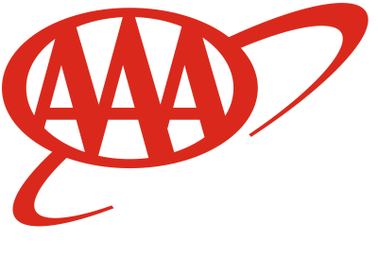
To: Members of the House Transportation and Public Safety Committee
From: Stephen Nielson, Ohio Conference of AAA Clubs
Date: April 25, 2019
RE: Proponent Testimony, House Bill 51

My name is Stephen Nielson and I am writing on behalf of the Ohio Conference of AAA Clubs, which is comprised of the six AAA Clubs in Ohio, and represents approximately 3 million Ohioans. I am writing in support of HB 51. AAA is dedicated to saving lives and minimizing traffic-related injuries by improving road safety through infrastructure improvements and by providing education on safe driving practices.

HB 51 requires Center Line Rumble Strips to be installed when there is new road construction or major road construction that already requires a road to be entirely torn up and repaved. This requirement will apply to roads with a speed limit of 45 miles per hour or higher. Rumble strips reduce the likelihood of a crash and diminish the severity of consequences in instances when a crash does occur.

In May 2017, the AAA Foundation for Traffic Safety released a report titled “Safety Benefits of Highway Infrastructure Investments.” The report identified six cost-effective highway improvements that can reduce the total number of highway crash fatalities and injuries in the United States. This report concluded, with a variety of highway infrastructure improvements, 63,000 lives could be saved, and 353,560 injuries could be prevented over the course of twenty years. Installing center and shoulder Center Line Rumble Strips accounted for nine percent of the total safety benefits in this study. That comes out to 5,670 lives saved and 31,820 injuries prevented just through their installation.

In an ideal world, all drivers would be focused while on the road. We all know that is not the case. A driver may be distracted, drowsy, or unable to see clearly due to weather conditions. Rumble strips alert a driver that they are drifting and can bring them back to focus. Highways should be developed and maintained in a manner that seeks to reduce crashes and minimize the severity when they occur. House Bill 51 seeks to ensure all future road development in Ohio is more forgiving of driver error, improving the safety of Ohioans.

Sincerely,

Stephen Nielson

