ALEXANDER ALBERT DRABIK, 1910 -1993
Hero of Remagen during World War II
When John Drabik and Frances Lewandowski were young children in Poland, their parents died in the 1873 cholera epidemic. Thirteen years later, they married in Saint Nicholas Church in Szymborze, Hohensalza, Posen, Prussia, Germany, now Inowroclaw, Poland. With their son Stanley (Charlie), they arrived at Castle Garden in New York City on March 30, 1888 on board the Rhein to seek liberty and a better life. After working in Toledo and saving for 11 years, they purchased 40 acres of farm land on Wolfinger Road in Sylvania Township, Lucas County, Ohio.
Alexander Albert Drabik, the youngest of 14 children, was born to John and Frances on December 28, 1910 in a log house on that Wolfinger Road farm. Alec did farm chores and attended Dorr Street Elementary School in Springfield Township. He was the family comedian to his many nieces and nephews – making funny faces, chasing them, playing games and cracking jokes. As a young adult, he worked as a meat cutter.
Alec enlisted in the United States Army in October 1942 for World War II. During a training exercise in California, Alex led 120 lost soldiers out of the desert. Sergeant Drabik was awarded the Purple Heart for rocket shrapnel wounds to his hands and feet during the Siege of Bastogne at the Battle of the Bulge, the last German offensive on the Western Front in late 1944 and early 1945. On March 7 of 1945, Sergeant Drabik led ten Company A soldiers of the 27th Armored Infantry Battalion of the 9th Armored Division across the Ludendorff Railroad Bridge from Remagen, Germany to Erpel, Germany on the Rhine River east bank.
Shortly before his retirement in the late 1970s, Drabik described that day in The Medusa Mirror: “All of us were surprised to see the bridge still in one piece. It was a railroad bridge with two tracks. The Germans had blown up the others along the Rhine. General Hoge [General William Morris Hoge, 9th Armored Division commander] called together the officers and non-coms and asked if we wanted to try to cross before it blew up. I think he’d already made up his mind.

“The Germans had explosives planted on and under the bridge. Some time after 3 o’clock, they fired the main blast. The old bridge went up in the air, but it came back down on its foundations. It was too tangled up for tanks to get across. OK for infantrymen.
“A few minutes later, my platoon was ordered to get going. I had an M-1 rifle, maybe 80 rounds in a bandolier, grenades and a rocket launcher. We got by the two guard towers at the west end and started
over. Our platoon sergeant – Joe DeLisio – cut wires attached to other charges. We thought the whole thing would blow up while we were on it. So we kept moving.

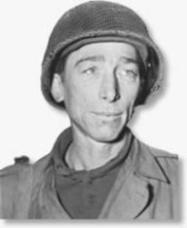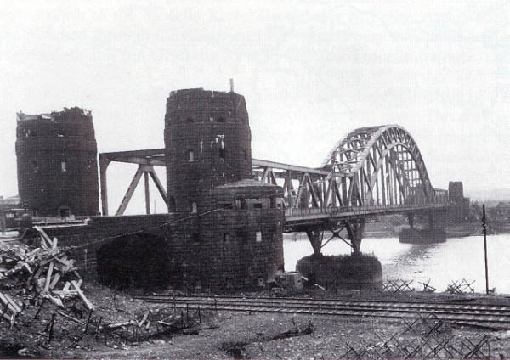

Sergeant Alexander Drabik Ludendorff Railroad Bridge/Bridge at Remagen
United States Army – Public Domain padresteve.com
“DeLisio went into a guard tower at the east end – the far end - and captured snipers there. I got to a little railroad station and cleaned it out. Just then a train loaded with 200 or 250 Germans came chugging in. We fired shots into the boiler. It blew up, and the soldiers jumped off.
“Up the hill, above the river, the enemy was dug in. We had only one company across the bridge. It wasn’t ‘til about midnight that our engineers got the bridge fixed for tanks to come over. Somebody put up a sign: Cross the Rhine with Dry Feet, Courtesy of the 9th Armored Division.”
Sergeant Drabik, the first Allied soldier in Nazi Germany, earned the Distinguished Service Cross for “extraordinary heroism in action against the enemy” and “unflinching valor” while establishing bridge- head on the Rhine. The actions of the Company A soldiers shortened the war by three to six months and saved tens of thousands of lives.
Drabik never truly enjoyed nor took advantage of his fame. During a radio interview in Paris, he was nervous. For him, the capture of Remagen Bridge was always about the team. At the city of Toledo celebration in August 1945, he said, “On March 7, I shared a great honor with my commanding officer and the men of the 9th Armored Division. They were excellent in combat. We worked as a team and won out.” He was hired as a consultant on a Hollywood film about Remagen; he left when he learned that the focus would be on his feats, and not the efforts of all his men.
After the war, Drabik returned to the farm, and worked as a butcher for Folger’s and Lengel Meats for 20 years and as a repairman for Medusa Portland Cement. He married Margaret I. Feeney on May 15, 1954. They raised a daughter Rita who married Dale Wilson; they enjoyed their grandchildren, Alexander and Katrina. Drabik was a past commander of Veterans of Foreign War Remagen Post 7372 and a member of the Joseph W. Diehn American Legion Post 468. He visited the Peace Museum Bridge at Remagen in the two surviving western towers, which contains the bridge's history and themes of war and peace. Drabik died on September 28, 1993 in a traffic accident in Columbia, Missouri on his way back from an army reunion. He was buried in Resurrection Cemetery next to Maggie.
Alexander Albert Drabik was a simple and ordinary man who lived the Polish-American values of hard work and loyalty to family, church and country. The extended Drabik Family erected an Ohio Historical Society marker at his birthplace, 9336 Wolfinger Road in Holland in 2011. He was posthu- mously inducted into the Ohio Military Hall of Fame in 2015. Confronted with a dangerous situation, he showed leadership and courage to bring that liberty, so cherished by Poles, to the peoples of Europe
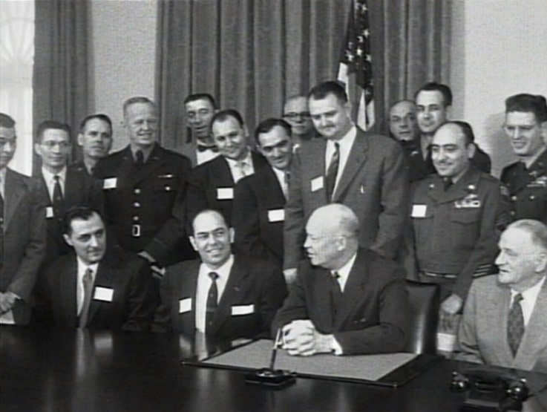
Soldiers across the Bridge at Remagen in order

Sergeant Alexander Drabik, Holland, Ohio
Private First Class. Marvin Jensen, Slayton, Minnesota
Staff Sergeant Anthony L. Samele
Technical Sergeant Joseph A. DeLisio
Technical Sergeant Michael Chinchar, Saddle Brook,
New Jersey
Private First Class. Artis L. Massie,
Staff Sergeant Carmine J. Sabia, Brooklyn, New York
Private First Class. Martin Reed, Assaria, Kansas
Private First Class. Joseph K. Peoples, Warrenton,

Society of the Remagen Bridge, White House
March 7, 1955 with President Dwight D. Eisenhower. Jacqueline Koralewski Konwinski, grandniece Drabik is in the back row, fifth from left. Critical Past

