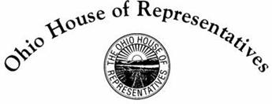

**Representative Phil Plummer**

**40th House District**

**House Bill 313 Sponsor Testimony**

Chairman Green, Vice Chair McClain, Ranking Member Sheehy, and members of the Transportation and Public Safety Committee. Thank you for allowing me to testify on House Bill 313. The Ohio Society Daughters of the American Revolution (OSDAR) is part of the National Society Daughters of the American Revolution (NSDAR). They are a non-political, women's service organization dedicated to Historic Preservation, Education and Patriotism. OSDAR was founded in December 1891 and is comprised of over 6200 women in 100 Chapters throughout Ohio. Their members are passionate about community service, preserving history and educating children as well as honoring those who have served or are currently serving our nation.  In the last three years, Ohio Daughters have given over 585,000 hours in service to our local communities. They serve as mentors and tutors, including over 2,900 hours of promoting literacy with children, and over 850 hours with adult literacy efforts.

The funds received through the license plate sales will go into the OSDAR General Fund. The use of monies will then be voted on by the OSDAR Board of Management to subsidize various OSDAR State committees and projects to include OSDAR owned historic property, the Christian Waldschmidt Homestead.  The Board of Management will ensure that the funds are used to support DAR values.