WRITTEN TESTIMONY TO THE HOUSE TRANSPORTATION AND PUBLIC SAFETY COMMITTEE

PROPONENT TESTIMONY

HB 202

October 1, 2019

Chair Green, Vice Chair McClain, Ranking Member Sheehy, and members of the House Transportation and Public Safety Committee, thank you for the opportunity to write in support of HB 202.
Ohio’s municipalities welcome the opportunity to take part in the increasingly important conversation surrounding electric vehicles and the steps Ohio and its local governments must take to prepare our infrastructure for this growing market.
Other states in the Midwest have recognized the importance of establishing committees like the one in HB 202 to ensure their states stay competitive in attracting and maintaining a strong workforce and a growing economy. The market for electric vehicles is poised to shift dramatically in just the next five to ten years. Ohio must ensure it does not fall behind its surrounding states by preparing for tomorrow’s infrastructure needs today.
Municipalities are home to 8.5 million Ohioans and contain 80% of all businesses in Ohio. Cities and villages will play a crucial role in ensuring transportation infrastructure accommodates the growing electronic vehicle market. HB 202 recognizes the role local governments will play in this transition and takes the necessary steps to gather data and start the conversation surrounding this important topic.
We want to thank Rep. Smith and Rep. Weinstein for recognizing the need for the Electric Vehicle Infrastructure Study Committee and we urge your support for this legislation.
Sincerely,
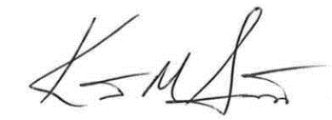

Kent Scarrett
Executive Director
Ohio Municipal League

