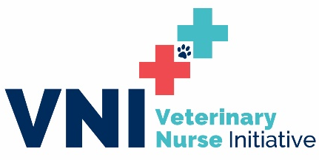
Ohio Senate Testimony
September 25, 2019

Dear Chairman Hoagland, Vice Chairman Schaffer, ranking minority member Senator O’Brien, and members of the Senate Agriculture and National Resources Committee,
My name is Kenichiro Yagi and I am from Ithaca, New York and I represent the Veterinary Nurse Initiative (VNI) led by the National Association of Veterinary Technicians in America (NAVTA). I am writing to ask you to support the change of the title “registered veterinary technician” to “registered veterinary nurse”. The VNI has the goals of standardizing professional standards, elevating public and professional recognition, and expanding career potentials for our profession around the nation.
I have experienced our professional challenges by working in the veterinary field for 19 years with earlier parts as a non-credentialed staff member, and as a registered veterinary technician for the past 11 years; I interact with veterinary technicians around the nation as an active certified veterinary technician specialist in Emergency and Critical Care as well as Small Animal Internal Medicine with a master’s degree in veterinary science and as the president-elect of NAVTA and previously as the chair of the national state representative system. Through exchanging of experience around the nation, it became clear we shared the challenges of poor public and professional understanding of our credential. The answer “Yes, absolutely” resonated at the national summit years ago where state and national leaders were asked the question of whether we need to standardize our credential under a single title of Registered Veterinary Nurse. I have been working with veterinary leaders across the nation since, to bring our goal to fruition.
NAVTA supports the veterinary professionals of Ohio in the proposed change as it will turn the state into the spearhead to a national effort in setting the standards for registered veterinary nurses for the rest of the nation to follow. The educational standards set for individuals to qualify and to maintain credentials in Ohio will serve as examples for other states to mirror and to pursue. Once the standards are nationally unified under the title of registered veterinary nurse, license portability will be improved through the ability to form agreements between states for registered veterinary nurses to utilize their education and degree in any state while still allowing each state to regulate its own credentialing. License portability and reciprocity is important in today’s world of increased mobility of households and will also support military families being stationed outside of their home state for duty. With the current national trend of insufficient qualified individuals with necessary education to fill the role, an accurate and recognizable national title will draw qualified individuals to enter and stay in the profession, as well as driving public protection nation-wide and secure the future of veterinary medicine.
Thank you for the opportunity to testify today in support of the title change. I would be happy to answer any questions that you may have.

Kenichiro Yagi, MS, RVT, VTS (ECC, SAIM)
NAVTA President Elect, Veterinary Nurse Initiative Co-Chair

