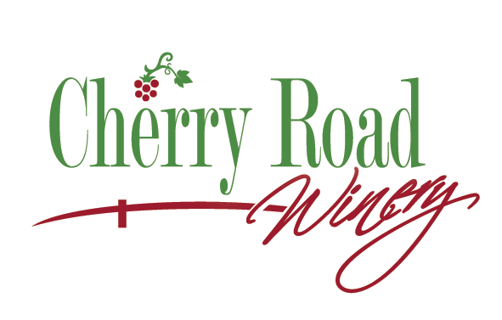
Cherry Road Winery, LLC
1133 27th Street, N.W.
Massillon, OH 44647
330-265-5807

October 21, 2019
Dear Chairman Hoagland, Vice Chair Schaffer, Ranking Member O’Brien, and members of the Senate Agriculture and Natural Resources Committee,
Thank you for the opportunity to present proponent testimony on Senate Bill 195.
First of all, we appreciate the initial efforts of the Legislature to allow small wineries to operate within structured guidelines to offer prepackaged food to customers under exemption of the requirement of a retail food permit.
Cherry Road Winery, LLC is a small production winery on the west side of Massillon, situated in Stark County, Ohio and the holder of an A-2 liquor permit for the sole purpose of the manufacture of wine. The winery has been in existence since 2016. The business meets all of the regulations of the Ohio Division of Liquor Control to maintain the A-2 permit, which includes an operational three-bay sink for washing, rinsing and sanitizing wine glasses, and a separate staff handwashing sink (not in the restroom). Cherry Road Winery, LLC also meets the requirements of the federal government’s Tobacco Trade Bureau (TTB), having been physically inspected by the TTB in 2017 of both production and tasting room facilities.
The current annual production of wine at Cherry Road Winery, LLC is just over 1,000 gallons a year. Since opening the business we have seen the need to add commercially prepackaged food, such pretzels, chips, and crackers, in order for customers to have something to eat while tasting the various wines produced. We are limited in space and therefore cannot add a kitchen to prepare or handle food. We are interested in selling prepackaged food that is obtained from a vendor already holding a food processing permit.
In obtaining the A-2 liquor permit, the winery was not required to have a retail food license for the wine because, as noted above, the production and tasting of wine is already regulated under various state and federal entities. The language, as passed in July 2019, protects the consumer by requiring that the only food offered for sale is commercially prepackaged. The legislation allows small wineries to operate without the additional financial burden of a retail food license.
Therefore, the language proposed in Senate Bill 195 is appreciated, and it is necessary in order to clarify that the sale of wine shall not be included in prepackaged food when determining the 5% cap of total sales, which is part of the structured guidelines that were originally approved.
Thank you once again, Chairman Hoagland and the members of the committee, for the opportunity to testify on this issue to you today.
Sincerely,
Judith A. Robinson
Judith A. Robinson, Owner

