Ohio Mayors Alliance
Interested Party Testimony on House Bill 168
November 13, 2019

Chairman Hoagland, Vice Chairman Schaffer, Ranking Member O’Brien and members of the Senate Agriculture and Natural Resources Committee, thank you for the opportunity to provide testimony on House Bill 168:

For the Ohio Mayors Alliance, a bipartisan coalition of mayors in Ohio’s largest cities and suburbs, brownfield redevelopment is a key issue to the economic development of our cities and the entire state. This bill would establish an affirmative defense to a release or threatened release of hazardous substances from a facility for certain bona fide prospective purchasers.

Brownfield redevelopment is a critical component of economic development in many of our cities and our mayors and their public and private counterparts support reforms to Ohio law that would encourage more brownfield redevelopment in the private sector. House Bill 168 is one such reform that would place Ohio and its communities at a competitive advantage and encourage economic development in the state by incorporating the Bona Fide Purchaser Defense (BFPD) in Ohio law.

Under HB 168, purchasers of the contaminated brownfield can establish defense to environmental liability by completing a number of steps, “All Appropriate Inquires”, to show due diligence and if any of these steps indicate contamination, the buyer must take reasonable steps to stop ongoing releases and prevent exposure. The goal is to make the property safe for reuse and prevent any ongoing threats to the environment.

The liability for contamination can be a real and pervasive deterrent for prospective purchasers of brownfields. In 2002, Congress passed the Brownfield Amendments to enhance protections for innocent purchasers, including the BFPD. But in all these years, Ohio has not codified a law to mirror this, as other states have including Indiana and Michigan, putting Ohio’s brownfields at a disadvantage.

HB 168 would bring Ohio law in line with federal law through enhanced liability protections for innocent purchasers of contaminated purchasers. We believe Ohio needs to continue to incentivize brownfield redevelopment for the economic benefit of the state and ensure we remain competitive with other neighboring states. HB 168 would address an important gap in Ohio law.

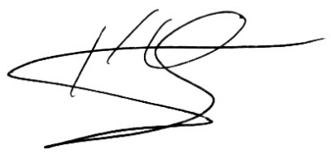
Respectfully submitted,

Keary McCarthy
Executive Director, Ohio Mayors Alliance

