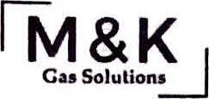
Greetings Chairman Hoagland, Vice Chair Schaffer, Ranking Member O’Brien, and members of the Agriculture and Natural Resources Committee,
Let me first thank you for taking the time to read through our experience regarding House Bill 160 Revising Alcohol Ice Cream. We are M&K Gas Solutions, an Ohio based industrial gas supplier, and have the privilege of partnering with Buzzed Bull Creamery in their national franchising expansion through provision of liquid nitrogen which is a foundational resource used in making their products. Through this partnership, we see firsthand the accelerating growth and demand for their product line.
Buzzed Bull Creamery, along with many other creameries throughout the country, offer alcoholic and nonalcoholic ice cream recipes to customers within their venue. Over the past year of our partnering, we have seen Buzzed Bull Non-Alcoholic Pints put on the shelves of Jungle Jim's. Their product sold well, but the personal and social media outreach from customers centered around asking when the "Buzzed" (Alcoholic) variety was going to be hitting the shelves.
Through the combination of sales growth, customer response, and franchising expansions, we know that this is a concept that will exponentially grow in Ohio. We fear that in passing up on this opportunity, the industry will be forced out of Ohio into states more friendly to this new concept. As a native Ohio company, this potential discourages us deeply.
Approving this bill will help a variety of industries, but most importantly small Creamery businesses that serve or aspire to serve alcoholic ice cream. They will have access to new avenues of growth as it would allow them to now serve their customers in the comfort and safety of their home by either a delivery system via the store or by the consumer purchasing the product from the store and returning home.
In summary, through the passing of this bill we see increased employment opportunities in Ohio as the increased growth will demand Ohio workers. We see a boost in tax revenue that benefits Ohio instead of her neighbors, and we see the benefits to additional parties involved as venders and partners. Ohio stands to gain with this bill.
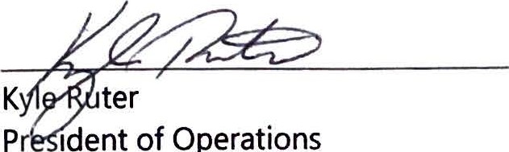
Regards,
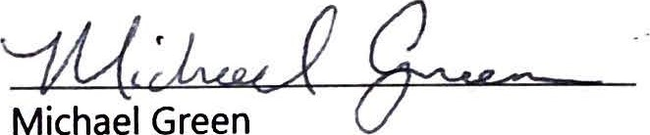

President of Finance

