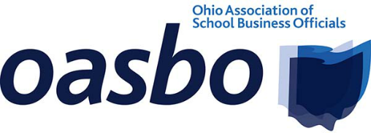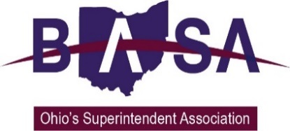

Senate Education Committee
Written Testimony on Academic Distress Commission Proposal
Ohio School Boards Association
Ohio Association of School Business Officials
Buckeye Association of School Administrators
June 13, 2019
Chairwoman Lehner, Vice Chairman Terhar, Ranking Member Fedor, and members of the Committee. Thank you for the opportunity to provide written testimony on the proposal to change Ohio’s Academic Distress Commission (ADC) system currently being considered by the Senate for inclusion in the budget bill, Substitute House Bill 166.
We think the proposal is extremely complicated and relies too heavily on state level decision-making. It creates a new bureaucracy with the School Transformation Board, delegating functions to this new board that would otherwise be the role of the Department of Education or the State Board of Education. These provisions alone are cause for concern for our organizations and our members.
By requiring state intervention on a district basis rather than by school building, the proposal would undermine the good work districts are already doing (much the same as with the current ADC system). The proposal essentially sets up three different pathways for affected districts, which will cause unnecessary confusion and treat districts differently. For instance, we believe the same opportunities made available for districts/buildings that might need help in the future could also be applied to the three districts already under ADC control. Yet the proposal restricts those districts controlled by an ADC currently to new restrictions.
It is our position that districts need support and resources from the state, but local leaders must be permitted to devise a local plan for success. We believe that armed with the proper tools and supports, communities and districts will achieve successful outcomes for their students.
As you are aware, we are in support of the proposal as contained in the House version of HB 166 (taken from HB 154, a bipartisan proposal) which provides a pathway for local districts and communities to determine the needs of their districts, including a plan to get there. The proposal distributed this week is complex and far-reaching; too much so to properly vet and enact in such a short amount of time.
The steps already contained in the House budget bill would go a long way toward improving things for schools, communities and most importantly, for students. We urge you to reject this proposal and proceed more cautiously with any further changes that might go beyond the pathway set forth by the House. Ohio does not need more bureaucracy ~ we need to empower those who have the most potential to make a difference.
This concludes our testimony. Please feel free to contact us with questions.

Respectfully submitted,
Jennifer Hogue, OSBA, Director of Legislative Services ~ 614-540-4000
Tom Ash, BASA, Director of Governmental Affairs ~ 614-846-4080
Barbara Shaner, OASBO, Advocacy Specialist ~ 614-325-9562

