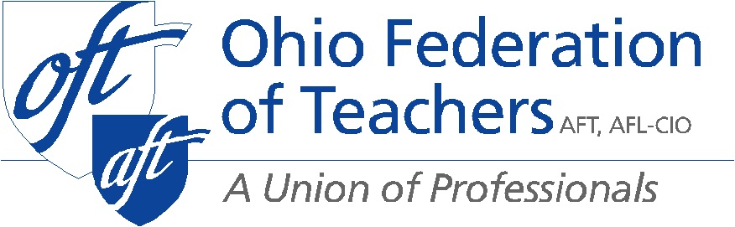

Senate Education Committee
Interested Party Testimony HB 154
Presented by Darold Johnson
Director of Legislation
September 10, 2019

Chair Lehner, Ranking member Sykes, and members of the Senate Education Committee thank you for the opportunity to testify today. I am Darold Johnson, Legislative Director for the Ohio Federation of Teachers. OFT represents over 15,000 members, including teachers, paraprofessionals, nurses, higher education staff and faculty, and public employees.
I am here today to testify as an Interested Party on HB 154, a bill which passed the House with bi-partisan support in the House Education Committee, 13-2, and the full chamber 83-12. HB 154 has the potential to change the current model of school turnaround in this state from one that is punitive and takes away local control, to one that identifies schools with challenges earlier and provides steps for how the local community – including teachers, administrators, parents, and community stakeholders – can work together to improve outcomes for students.
This current version (I_133_1654-1) not only identifies steps but also provides resources to districts so that they have what they need to overcome their identified challenges and implement their locally developed plans.

To strengthen this bill even more, OFT suggests the following changes, in the order in which they appear in the bill:

The School Transformation Board (3301.28)

- We suggest expanding the number of people who comprise the School Turnaround Board to seven members, either by expanding the members appointed by the Governor or expanding the number of people who make appointments to the board to include the Governor, Speaker of the House, President of the Senate and the minority leaders of the House and Senate including the Superintendent of Public Instruction and Chancellor. We also want to have members of education organizations, including unions, make recommendations to each for appointment to the Board. A bi-partisan approach to appointments recognizes that more than one party has a stake in improving education for all Ohio children. Education should not be a partisan issue.
- We suggest redirecting the money allocated for the School Turnaround Board to the Ohio Department of Education (ODE) to develop best practice methods to assist school buildings in the lowest performing ten percent before a school district gets its first F.
- Members of this board should be free of any conflict and free of any interest or association with any company receiving funds for turnaround.
- Eliminate the for-profit providers from eligibility for selection as turnaround experts.

ODE Development of School Improvement Experts

- Lines 50- 58 charge the department with creating a list of school improvement experts or organizations that provide root cause analyses or school improvement supports.
- We would add language stating that any organization that provides supports must have a track record of using a coaching/train-the-trainer model that builds capacity within a district or school for both the teachers and administrators. Building local capacity is critical for ensuring sustainability in a school district. The state should also work on building capacity in the Department of Education and in other existing bodies to work with school districts on school improvement. Furthermore, we would add that the state must begin to build a repository of best practices from throughout the state by tapping into already existing resources that we have in Ohio. ODE shall be a place where similar districts can share what they have done locally to meet similar challenges.
- Also, as districts learn from the improvement specialists the state is funding, their learning can be added to the repository so that we can begin to build our expertise in Ohio state.
- The ODE must work from a definition of expertise that is clearly defined. We want to avoid the scams that arose when No Child Left Behind created money for tutoring services.

Clarification of Period Before State Takeover

Lines 103-124 refer to a district having the ability to contract for services for three years with an option for an extension for up to two years. It then refers to a district being subject to Section 3302.10 after its sixth F Since a district cannot be funded for the improvement contract until it receives its second “F,” a five-year contract would put it at its seventh “F” before being subject to 3302.10. This is still very reasonable as a district cannot get the two-year extension unless it is making progress on its identified goals. This is just a clean-up of language. This change would also need to be made in lines 234-237.

Root Cause Analysis and Collective Bargaining

Lines 274-285 list what would be included in a root cause analysis. We request that lines 282-283 be excluded from this list. District policies and collective bargaining agreements are not in and of themselves root causes of problems in a district. Both may deal with issues that might be determined to be root causes, but blaming the policy or contract itself runs the risk of masking the underlying cause. A root cause analysis should identify the issue causing the barrier (for example – not enough time in school day, a need to move teachers to different buildings), then the district should determine in its locally developed plan how it will deal with the issue which may include re-visiting Board policy or re-negotiating that provision of contract.

School Improvement Teams

Lines 335-359 mention who should be included on a school improvement team. While we appreciate the inclusion of a teacher on this team, we don’t understand why the teacher is a non-voting member. We ask that the teacher be given the same voting privileges as other members of the team. If the concern is that a vote could end in a tie because there are six people on the committee, we suggest that the state superintendent only appoint two members instead of three. Making this change would still give three votes to people not directly tied to the district (two superintendent appointees and one member from business community) while also giving voice to two people who represent the district (president of the school board and teacher) which would go a long way toward getting buy-in from both the community and educators.

Collective Bargaining and State Takeover

While the Senate version has potential to help districts overcome difficult challenges, it will not provide adequate help and support as long as it still holds the threat of eliminating educators’ collective bargaining rights and gives unilateral control to one individual. That is exactly what this bill does once a school becomes subject to section 3302.10.

As we said before, a collective bargaining agreement is not the root cause of problems in a district. Taking away these rights is a punitive measure that has not been proven to improve the conditions of a school. Collective bargaining often enhances the learning conditions of a school, as we have seen with our most recent agreement at Summit Academy in Parma. Collective bargaining is a process that brings together both labor and management to determine how to address an issue, or root cause. Rather than eliminating the collective bargaining agreement, we suggest language that states if a root cause analysis identifies an issue for the district to address for which a provision exists within the CBA, then that provision of the CBA only must be re-opened for negotiations. By doing this, teachers will be able to bring solutions to the table on how to address a problem rather than one individual making a unilateral decision. Collective bargaining is a process which has historically been used to improve conditions within districts, including adding more nurses and counselors, providing for peer coaches or re-structuring how time is used throughout the day. For example, when the “Cleveland Plan” was introduced, it was done without the input of teachers. Thankfully, Senate President Niehaus allowed Cleveland teachers to come to the table with several new creative ideas that got incorporated into the plan, such as year-round schools and tutoring embedded in the learning day.

Exiting the Academic Distress Commission

We support clarifying how current ADC districts can be released from the current ADC model with a plan, and clarifying that if they want to continue the current model they can so choose.

Again, you must strike the language ending collective bargaining under the school improvement takeover board. Collective bargaining is a means for dialogue, and a right that has been upheld by over 60 percent of Ohioans.
We request that you include language eliminating the current ADC model and releasing those districts that are currently under an ADC. They should be able to submit a plan for next steps to the School Transformation Board with the option to receive one hundred percent state funding from an organization approved by ODE.

Thank you for allowing us to testify today, this concludes our testimony and I welcome any questions you may have.

