LWVO Testimony on
Sub HB6 – Clean Air Program
Alan R. Rosenfield, ScD FASM
alanpeg@alum.mit.edu
Senate Energy and Public Utilities Committee
June 18, 2019

HB6 is a deeply flawed bill. It needs to be replaced entirely. The bill is based on faulty assumptions and has been amended to make a travesty of its title.

This legislation has one saving grace – the guidelines reported by the sponsor shortly after it was introduced. We believe that these guidelines should be the basis for a new clean air bill.

Attaining the lowest possible carbon footprint
Motor vehicle operation is now the largest source of CO2 emissions in the United States. Electrical generation is slightly behind at about one-third of the total. In other words, Sub HB6 should be replaced because it ignores two-thirds of Ohio's carbon footprint.

According to advocates, Ohio's reactors prevent nine million tons of greenhouse gases being emitted each year. Since Ohio emits about 200 million tons annually, reactor shut-down would lead to a 4.5 percent increase. This is in line with the small emission changes after reactor shut-down in other states (See table 1 in the Appendix).

Energy efficiency is a much more cost-effective way of reducing greenhouse gas emissions. Ohioans are lowering the state's carbon footprint by using energy efficiency and thus preventing about as much greenhouse gas emissions as do nuclear plants. HB6 should be replaced because it phases out Ohio's energy efficiency program. We need a robust energy-efficiency program, that involves all sources of pollution, not just electrical generation.

Ensuring lower consumer costs

Closing the two nuclear plants will have little effect on electric rates. Despite theoretical claims to the opposite, electric rates will not rise steeply, nor will raises persist for a number of years. We know this because rates have not risen sharply in other states where reactors have closed (See Table 2 of the Appendix).

Renewable energy is another cost-effective way of reducing greenhouse gasses. Nationally, renewable energy is rapidly approaching nuclear as a provider of greenhouse-gas free electricity. Ohio is not taking advantage of it and ranks 48th in the union for renewable energy due to continual roadblocks being enacted. HB6 adds one more bureaucratic obstacle. HB6 should be replaced to retain the renewable-energy goals of 127-SB221 and return the setback requirements to their earlier values.

Making the state more energy self-sufficient.
Renewable energy actually satisfies all three objectives. Supporting a coal plant in Indiana does not make Ohio more energy self-sufficient, nor does supporting an out of state nuclear facility.

Concluding Remarks

If Sub HB6 had been introduced twenty, or even fifteen, years ago, it would have been considered forward thinking. Sadly, the legislation does not reflect the changes since then. Particularly, energy-saving and truly renewable technologies have advanced rapidly to where it should be a major part of any clean air legislation. Fossil fuels and nuclear should not.

Appendix*

Background Information on Reator Closings

Seven reactors in six states have closed in recent years. Data from the Energy Information Administration shows us how much greenhouse gas emissions and electric rates changed since the closings.

Since there are no statewide emissions data beyond 2016, we can only show changes for four of the states. The other reactors closed too recently. Emission rates have hardly changed since the reactors were shut-down.

Table 1. Greenhouse-Gas Emissions Since Reactor Shut Down

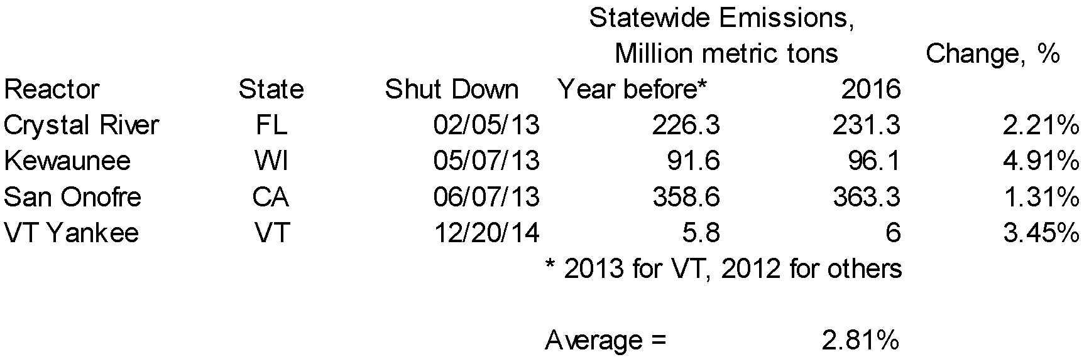

Table 2 shows that electric rates have hardly changed since reactor shut-down. In fact, rates have gone down in two of the states.

Table 2. Electric Rate Changes Since Reactor Shut-Down.

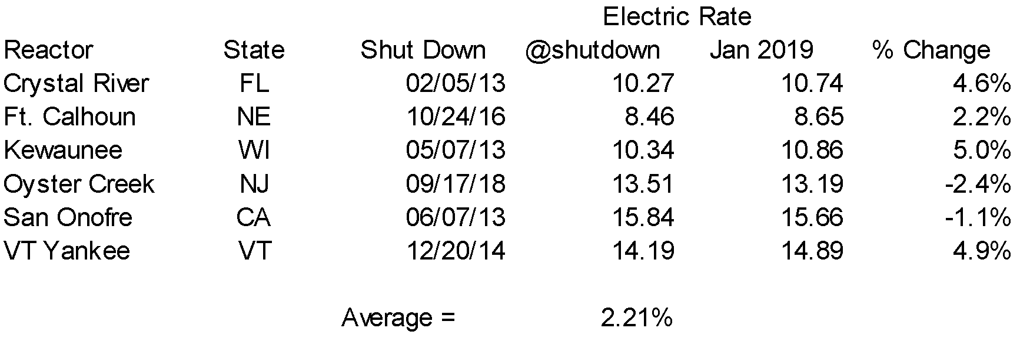

* All data from Energy Information Administration

