Senator Matt Dolan
Senate Finance Chairman
1 Capitol Square 1st Floor
Columbus, OH 43215

RE: TESTIMONY IN SUPPORT OF AN AMENDMENT TO SC 2833

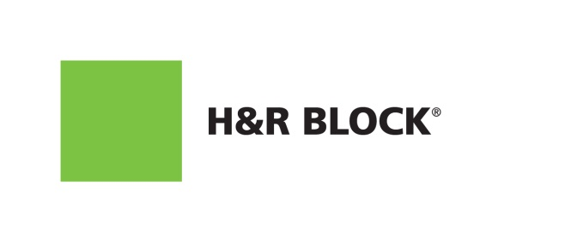
Mr. Chairman and members of the Committee: on behalf of about 368 H&R Block offices and over 3,000 highly trained tax professionals in Ohio, H&R Block appreciates the opportunity to comment and support an amendment to HB 166 that would allow the state to identify unscrupulous and unqualified tax preparers and prevent bad actors from operating in Ohio.

H&R Block believes that we – and all tax preparation companies – have a responsibility to work alongside our partners in government to fight tax refund and identify theft fraud. We appreciate the efforts of the Department of Taxation and members of the Legislature in advancing this shared goal.

This amendment requires paid tax return preparers to include their IRS Preparer Tax Identification Number (PTIN) on Ohio income returns. The PTIN is a unique identifier that all compensated preparers must currently obtain and provide on the federal tax return. Requiring the inclusion of the PTIN on Ohio tax return, as it is required on Federal returns, ensures tax preparers are legitimate actors. It also enables the Department of Taxation to bring suit to enjoin tax preparers from further engaging in criminal, fraudulent, and other reckless conduct or from acting as a tax preparer in the state.

Several states, including Alabama, Delaware, Indiana, Illinois, Louisiana, Maryland, Minnesota, and Virginia, have already taken similar action, tightening rules for professional preparers, to protect taxpayers and are seeing impressive results. Maryland, for example, has stopped $206 million in fraudulent payments since 2007. This common-sense amendment will protect Ohio taxpayers and the Treasury from fraud or costly mistakes through incompetence.

H&R Block has excelled for over 60 years as an industry leader because of our commitment to competent, ethical tax preparation. Unfortunately, not all tax preparers share this view. Each day, unscrupulous preparers seek new and exploitive ways to steal from the taxpayers of Ohio. All too often, their actions do the greatest harm to individuals who can afford it the least.

This amendment to SC 2833 would provide the state of Ohio greater enforcement power over fraudulent preparers and help protect consumers.

H&R Block supports this effort by the bill sponsor.

Andrew Jennison
Vice President, Government Relations
H&R Block
andrew.jennison@hrblock.com

