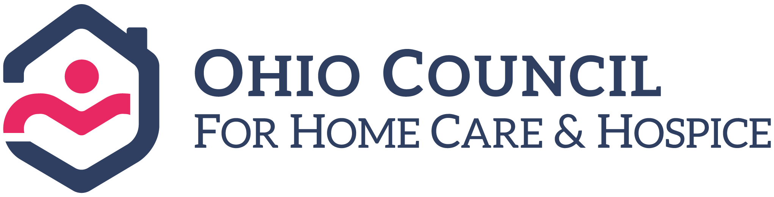
Testimony on Am. Sub. House Bill 166
Joe Russell—Executive Director
Ohio Council for Home Care & Hospice
May 28, 2019

Chairman Dolan, Ranking Member Sykes, and Members of the Senate Finance Committee, thank you for allowing me to provide testimony today on amended substitute HB166. My name is Joe Russell and I am the Executive Director at the Ohio Council for Home Care and Hospice (OCHCH). I’m testifying today to ask for your support to increase Medicaid home health skilled care rates.

Today, Ohio is dangerously close to a crisis point in its home health Medicaid program because home health providers are unable to cover the costs of providing care. These agencies are beginning to discharge their Medicaid caseloads due to appallingly low reimbursement rates and the inability to recruit and retain qualified providers. In fact, Home health rates are less today than they were in 1998.

Just like businesses in other sectors, home health agencies are now faced with making tough decisions about the future of their businesses and what services make most economic sense to continue offering. A significant gap in rates exists between Medicare and Medicaid that makes it much more difficult to accept Medicaid patients when given the choice between the two. Medicare pays three times more for home care skilled care services than does Medicaid. Serving Medicaid patients with such a disparity in rates for the same services that are provided under Medicare is simply not a business model that can be sustained by even the best of providers. We’re at the point where we need to seriously consider what the state will do when thousands of vulnerable Ohioans are left without the ability to stay home, and Medicaid spending continues to sky rocket due to the use of exorbitantly more expensive institutionalized care for these individuals. The time to invest in home care is now. We cannot wait any longer – we have already been waiting for over two decades for an investment in this area.

Although we had at least a dozen witnesses testify to emphasize the need for greater investment in home care services, unfortunately we were left out of the House passed version of the bill. We believe it was due in part to the confusion surrounding many similar sounding services for long term care (i.e. home care, assisted living, nursing homes, skilled care, etc.). Our proposed amendment is different than what has already been included in HB 166 with regard to the Assisted Living Waiver increase, PASSPORT Waiver increase, DD wage increase and the monies that were given to the nursing homes. We appreciate the investment the House has made to care for this vulnerable population through the various programs mentioned above. Unfortunately, however, the House missed a big piece of the long term care system: home care. Home care needs to be part of the overall investment in the long term care system or the ability to provide cost efficient services for these patients is going to rapidly diminish.

The bottom line is that Ohio must stabilize home health rates to avoid the pending crisis that could leave thousands of Ohioans without care. To address this issue, OCHCH is pleading with the Senate to include a budget amendment that would provide for a 10% increase to home care skilled care services. This modest investment would cost $28.6 million in total state share monies over the biennium. Our proposed increase would help home care agencies control costs of caring for Medicaid patients and ensure that this vulnerable population continues to get served. Additionally, this investment would help maintain a healthy workforce in the home care field that is so desperately needed.

Thank you very much for your attention to this important issue. I would be happy to answer any questions you may have at this time.

