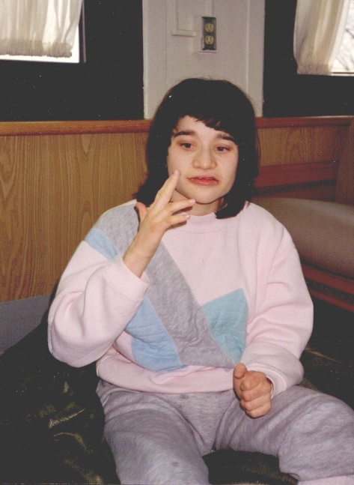

IN SUPPORT OF THE INFORMED CHOICE AMENDMENT

Chairman Dolan, ranking member Sykes, fellow committee members:

My name is Richard Klein, and I am the father and guardian of Shawna Klein, who just turned 47, and who resides at Stillwater Center in Dayton, Ohio. Stillwater is a 98-bed ICF/IDD facility owned and operated by the Board of Montgomery County Commissioners. Stillwater was newly constructed in April of 2003 and is designed with separated 16-bed and 12-bed homes with either private or semi-private rooms for each resident.

To understand the need for the informed choice amendment let me summarize our experience finding appropriate care for Shawna.

Shawna was born with profound intellectual and developmental disabilities (I/DD). Only 1-2% of the intellectually disabled population is classified as “profound.” Individuals with this level of disability have IQ scores under 25, functioning at an age level of nine months to two years. Shawna requires assistance in all aspects of daily living, including feeding, dressing, toileting and mobility. Shawna is non-verbal and without the presence of understanding nurses and caregivers is unable to communicate pain or discomfort for any injury or general illness.

Shawna lived at home in Greene County, outside of Dayton, until she was 9-1/2 years of age. During that time her mother and I cared for Shawna and sought treatment with doctors and local services for physical therapy and training. Her mother started a home patterning program with the help of volunteers and neighbors to teach Shawna to walk, with limited success.

Shawna received services through MRDD schools across three different counties, one of them a residential school where she was home on the weekends. Despite the specialized services she received through schooling, at 9 years of age Shawna was still unable to walk. Our family had grown during that time as Shawna has two sisters. Also, our marriage had become strained and we separated. We both knew that Shawna’s mother would need to go back to work and Greene County offered no solution to Shawna’s care. Shawna’s mother remembered one of Shawna’s teachers mentioning the State Development Centers. We toured Springview in Springfield and felt it was the best option for Shawna and our family. As difficult as the decision to have Shawna leave our home was, it was the right decision. She finally received the intensive supports she needed from people who were experts in the care of individuals with profound disabilities. The ICF placement paid off for Shawna. Within two years of on-site therapy she could walk after being assisted to a standing position. Shawna also learned to feed herself with assistive prompts. Shawna thrived at Springview as a child and then as an adult. Director Davis testified that the DC’s were not designed for children, but they were originally very much designed for children, and it was the DC’s expert care that gave my daughter the ability to walk.

The State of Ohio chose to close Springview and we chose to move Shawna to Montgomery Developmental Center. After five years at MDC, we became concerned about her safety at MDC as the population of residents that the center was accepting had changed. We sought for other options and learned about Stillwater from a personal friend.

At Stillwater Shawna is happy, well-cared for, and benefits from the interaction with the staff and other residents. She attends an adjacent workshop, Northview Center, accessible by wheelchair through a covered walkway. Shawna requires an integrated facility and requires 24/7 care and nursing services.

Our experiences in finding appropriate services and long-term care for Shawna are examples of the trauma faced by parents of the DD population. While the County Boards did provide schooling for Shawna, for which we are grateful, the County Boards were not a place where we could find care options, as unfortunately and honestly, I do not believe they respected our choice in care setting for Shawna. On March 20 of this year DODD Director Davis stated in his testimony and I quote “County Boards are the front doors to our system, providing intake, eligibility assessments and care management.” We need to require that all 88 diverse county boards inform their client families of all available services, including the ICF care facilities.

Thank you.

Richard H. Klein

