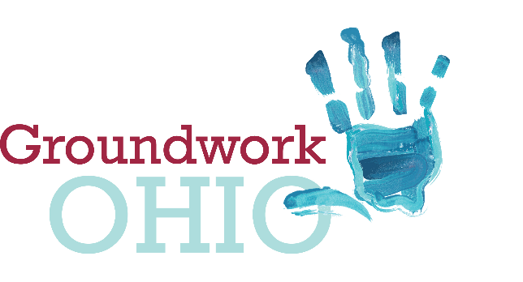
Lynanne Gutierrez
Policy Director & Legal Counsel
lwolf@groundworkohio.org
mobile: 614-204-6106
172 E. State Street, Suite 400
Columbus, Ohio 43215

Ohio Senate
Finance Committee
FY2020-2021 Operating Budget
Groundwork Ohio
Lynanne Gutierrez, Policy Director & Legal Counsel
June 5, 2019

Good Afternoon, Chairman Dolan, Vice Chairman Burke, Ranking Member Sykes and members of the Senate Finance Committee. I am Lynanne Gutierrez, Policy Director and Legal Counsel for Groundwork Ohio. Thank you for the opportunity to give testimony concerning Substitute House Bill 166, Ohio’s budget bill for state fiscal years 2020 and 2021. My testimony is limited to comment and concern on Ohio’s quality child care system, specifically Amendment SC3663.

As you know, the State has proposed a child care provider rate update based upon the unpublished 2018 Market Rate Survey. We continue to celebrate federal child care dollars being allocated to increased rates for child care providers as child care provider base rates have long been woefully out-of-line with the market rate studies for over a decade and rates are a critical piece to ensuring increased access to quality child care in our state. The proposed rate update was motivated by our state being in federal corrective action for insufficient rates and the guidance which requires Ohio to ensure that all base rates reach the low threshold of the 25th percentile of the market rate. This is supposed to equate to publicly funded children getting access to a mere 25% of the market in their community. The federal standard for equal access, as opposed to this incremental step in ensuring a sufficient floor for rates, is the 75th percentile. Unfortunately, while the overwhelming effect of the proposed 2018 Market Rate Survey implementation is very positive, 13 primarily rural counties will see an actual decrease in rates under the current proposal. We believe that as the state moves forward with their existing authority to update rates, this must be remedied.

In applying the federal guidance to the proposed implementation of the 2018 Market Rate Survey, two steps were taken. First, any existing rate that didn’t meet the 25th percentile was increased to the 25th percentile. Second, counties were clustered into three peer groups or rate categories. While 59 counties maintained the same category, 29 counties changed and 13 of those counties will see a decrease in rates because they are moving to a lower rate category. The market rate tool has been and continues to be an insufficient tool to set rates, particularly for rural counties. You will hear today in oral and written testimony how that is playing out and impacting local communities in the following ways:

First, the tool is insufficient for these counties because there is not a true market for child care in these communities. The data collected by the market rate survey often includes the rates providers are charging but not the cost of providing the quality service, given that providers are being sensitive to constricted incomes of private pay parents when setting rates in areas where we see concentrated poverty or even working class parents in these markets who cannot afford the full cost of delivering quality care. Further, if providers are heavily reliant on publicly funded children, they may under report the cost of delivering the service and instead report what the state actually pays them.

Second, many areas in these 13 counties or the entire county is a child care desert where there has never been child care capacity or where they have seen significant loss of capacity over time. As a result, there is insufficient data coming from stable child care programs to create an environment which allows additional child care programs to open and stay open. The most egregious of these cases is in Harrison County. Our understanding is that during the time period of the market rate survey there was one center and one family child care program in the entire county even available to provide data. This is certainly not because this county lacks for eligible kids who need child care. That center has now closed and the market rate survey tells us that Harrison should move not just one category down, but two. The market rate survey not only maintains an unsustainable environment for child care but perpetuates it.

Third, the idea that the cost structure is different in these particular counties is false. We as a state have required them all to deliver the same quality service with the largest cost driver being a workforce who makes on average, $10 an hour. The ability for programs to operate competitively and make decisions based on efficiency is limited, especially in communities where child care businesses are not operated by large chains but rather solo entrepreneurs and mom-and-pop shops. How can you justify, for example, a single center operating in the north corner of Preble County, bordering Montgomery and Darke Counties and serving kids from multiple counties whose parents are often traveling to Montgomery County for work receiving lower rates than their peers just a few miles down the road?

While we have responded to the insufficiency of the market rate tool for many smaller and rural counties during budget deliberations, we have also invited a greater conversation about the rate structure in our state based on this tool because of inequities it creates for infants and toddlers. The current rate structure actually encourages programs to serve preschool age children and discourages providers from serving infants and toddlers.

Lastly, the fact that the federal government has instructed the state that our rates are insufficient and we are in corrective action requiring us to bring the floor of our rates to the 25th percentile of the most current market rate survey, makes any decrease in rates for publicly funded children absurd on its face. Part of the solution to curing insufficient rates cannot be decreasing reimbursement to programs who struggle to stay open already. Typically, when rate adjustments occur, states will build in a hold harmless to protect against rates decreasing where, like Ohio, they are trying to actually build a quality child care system, not fill one whole to create another.

Accordingly, we ask for you to support amendment number SC3663, a “hold harmless” for child care providers serving children in the 13 counties (Allen, Ashland, Eerie, Preble, Sandusky, Seneca, Auglaize, Belmont, Knox, Ottawa, Portage, Trumbull and Harrison) that will see a rate decrease in the proposed rate update. These 13 counties, mostly rural communities, cannot afford to lose money given the critical work they do for children and families. At a time where they could actually benefit from a rate increase as they work towards meeting our state quality mandates, we are trying to maintain their status quo so that no children lose access to care.

We appreciate you listening to the testimony of stakeholders from many of the 13 counties here today in oral and written testimony. The counties represented include Allen, Ashland, Belmont, Preble, Knox Harrison and Trumbull. I have recently had many conversations with additional child care programs in these communities and I am confident that if they didn’t have to be working to maintain staff ratios and to create a safe, nurturing and developmentally appropriate quality learning environment, they would all be here to share their personal story with you. This change for these programs, who are pillars in their community, will be devastating. I spent this past weekend on the phone with them, many of whom are in tears not only because their business for which they have been working towards in many cases for over 25 years is at risk, but because they can’t fathom what happens to the children and families they serve without their care.

Thank you for your time and I’m happy to answer any questions.

