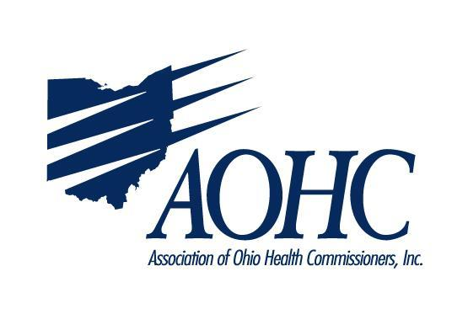

Testimony before the
Senate Finance Committee
House Bill 166
June 17, 2019

The Association of Ohio Health Commissioners (AOHC) is pleased to present this written testimony regarding Amended Substitute House Bill 166. We believe the proposals listed below further strengthen the bill’s intent to improve the health of all Ohioans.
- Tobacco Prevention and Cessation – Thank you for maintaining the proposal to increase the legal age to purchase to 21 statewide. We also appreciate the addition of vaping products to the list of other tobacco products that are taxed by the state. Increased age requirements and additional cost are both proven mechanisms for deterring young people from starting to smoke. Research shows that if a person does not start to smoke before age 21, they are much less likely to start.
- Help Me Grow/Home Visiting – Please restore the $10 million cut in the most recent version of the bill line item 440459. Ohio ranks among the worst in birth outcomes and avoidable infant deaths. This upfront investment will reap great benefits and return on the investment in the prevention of untoward birth outcomes.
- Public Health Priorities Fund – Please restore the $2 million cut in line item 440669. This investment will allow ODH to pursue critical public/private partnerships to fund public health initiatives without the need for additional GRF dollars in the future.
- H2Ohio Fund – thank you for establishing and funding this initiative to protect Ohio’s water supply. Local health departments throughout Ohio work in our communities to help address non-point source pollution which can lead to water quality problems including harmful algal blooms. A long-term funding plan is important to address issues around water quality and protect our valuable water resources. The creation of this fund will allow water quality initiatives, ranging from agricultural concerns to local sewage treatment systems, to have a long term impact on water quality. We look forward to working with the administration on initiatives to solve this important issue.
- Public Health Emergency Declaration – AOHC hopes that any issues can be resolved, so that this authority can be included in the final proposal. The current multi-state measles outbreak is a good example of why this authority would be useful in Ohio. Many other states have similar language, which allows access to greater resources, especially at the federal level, in the case of such response efforts.
Thank you for your valuable time. AOHC contact information:
Beth Bickford, Executive Director
110 A Northwoods Blvd., Columbus, OH 43235
614-781-9556, cell 614-832-0336

