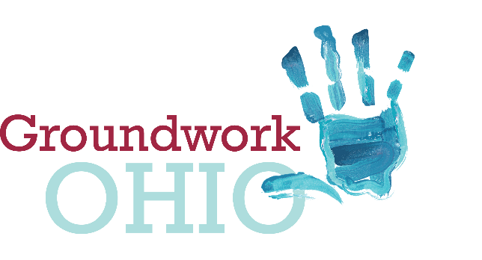
Lynanne Gutierrez
Policy Director & Legal Counsel
lwolf@groundworkohio.org
mobile: 614-204-6106
172 E. State Street, Suite 400
Columbus, Ohio 43215

Ohio Senate
Finance Committee
FY2020-2021 Operating Budget
Groundwork Ohio
Lynanne Gutierrez, Policy Director & Legal Counsel
June 17, 2019

Good Afternoon, Chairman Dolan, Vice Chairman Burke, Ranking Member Sykes and members of the Senate Finance Committee. Quite simply, thank you for listening to the dozens of early childhood professionals who urged your attention to the critical issues facing Ohio’s young children. We are grateful for your time, attention, and support of vital investments in the more than 120,000 kids supported by our publicly funded child care system each year.

Specifically, we thank you for supporting a “hold harmless” for child care providers serving children in the 13 rural counties that would have seen a rate decrease in the proposed rate update. Rates are a critical piece to provide access to quality child care for poor working families and their children. We applaud the Senate for maintaining the status quo and ensuring that no children lose access to care as a result of rate updates.

We also thank you for your support of an additional $10 million state GRF in FY 2020 to support quality infrastructure grants. This investment creates a competitive opportunity for early childhood stakeholders to satisfy one-time needs that support child care programs becoming quality rated to meet our 2020 and 2025 statutory mandates for serving more children in quality child care programs.

Like any other investment in our state’s infrastructure, this investment will pay dividends—not just to families and children who rely upon child care—but by providing a more consistent workforce to current employers, attracting new businesses to the state, improving local communities, and supporting our state’s long-term economic success.

Thank you.

