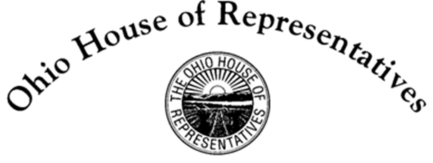

Brett Hudson Hillyer
State Representative, 98th House District

David Leland
State Representative, 22nd House District

Chairman Dolan, Vice Chairman Burke, Ranking Member Sykes, and members of the Senate Finance Committee, Representative Hillyer and I stand before you today with the distinct honor and privilege of providing sponsor testimony on House Bill 5. As many of you may know, Representative Hillyer and I are very passionate about indigent defense and the importance that defense attorneys play in protecting our very civil liberties, many of which are contained in the 5th Amendment, the 6th Amendment, and the 8th Amendment.

In 1963, the U.S. Supreme Court, in Gideon v. Wainwright, established the principle that under the 6th Amendment to the Constitution the right to counsel is sacred, and that one must be provided counsel if a criminal defendant was unable to afford one.

Here in Ohio, that task falls on the Ohio Public Defenders Offices throughout the state. Given that 70% of all defendants facing jail time are indigent, that translates into a high case load for these Public Defenders.

These high caseloads mean less time and attention to individual cases, trial delays, and potential wrongful convictions or inappropriate plea deals. In other words, a potential lack of Justice.

While being a Public Defender provides a lot of experience for young attorneys, one thing it doesn’t provide is enough money to service the average law school debt of $98,000. For this reason, House Bill 5 appropriates $1.5 million in FY 2020 and $1.5 million in FY 2021 to provide some relief to those seeking to uphold our 6th Amendment right to legal counsel

House Bill 5 provides a framework in which a young attorney can work for the Public Defender’s Office while still receiving a benefit to offset the cost of legal education. The financial benefits are as follows:
- Up to $50,000 (full-time) or $25,000 (part-time) for initial three-year contract
- Up to $35,000 (full-time) or $17,500 (part-time) for additional fourth and fifth year commitments

House Bill 5 will have a service commitment however, with the following criteria:
- Minimum three-year service commitment
- Optional fourth and fifth year service commitments
- Full-time (40 hours per week) or Part-time (20-39 hours per week) options

In addition to the requirements, Representative Leland and I would like to add a point of clarity. The Public Defender Loan Repayment Program is not for rural areas only. The program can be utilized in counties that are determined to be a “shortage area.” However, most underserved areas happen to be rural counties, but the bill does not explicitly limit it to such.

However, coming from rural eastern Ohio, I have often seen the challenges our local Public Defender’s Office has had in keeping young attorneys to stay with the office. It is our belief that House Bill 5 will help end the brain drain that occurs in particular areas of the state, while upholding the constitutional demands under Gideon v Wainwright and ultimately, provide good indigent defense services by attracting top talent for these jobs.

Representative Leland and I believe it is also important to note that House Bill 5 is designed in a very similar fashion to those loan repayment programs created for many medical professions such as doctors and dentists, encouraging folks to help aid underserved areas while paying off a large debt.

In addition to creating the Public Defender Loan Repayment Program, House Bill 5 will also create a 16-member Indigent Defense Task Force Study Committee. The Study Committee:
- Will study Ohio’s indigent defense system and provide recommendations to the General Assembly regarding the delivery, structure, and funding of indigent defense
- Requires the task force to report its recommendations to the General Assembly no later than August 1, 2020
- Requires LSC to assist the task force as needed
- Permits the task force to reimburse the travel expenses of any experts invited to present to the task force
- Earmarks $9,100 in FY 2020 and $900 in FY 2021 from GRF appropriation item 019401, State Legal Defense services, for this purpose

By passing House Bill 5, we will enable and empower Public Defender’s Offices the ability to hire competent staff who are willing to not lonely learn the rule of serving the community at large through indigent defense, but most importantly keeping that talent for a period of years. Furthermore, we will create a body that review the entire indigent defense system and develop recommendations so that the General Assembly may renew the indigent defense system to better serve the citizens of Ohio.

Chairman Dolan, Vice Chairman Burke, Ranking Member Sykes, and members of the Senate Finance Committee, thank you again for the opportunity to provide sponsor testimony on House Bill 5. We will be glad to answer any questions.

