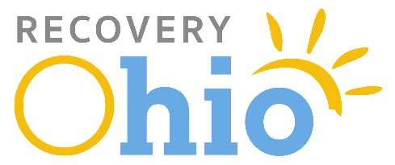
Good afternoon Chairman Schuring, Ranking Member O’Brien, and members of the Senate General Government and Agency Review Committee. Thank you for the opportunity to submit written testimony regarding my support for House Bill 10 (Brown, Stoltzfus). My name is Alisha Nelson, and I serve as Governor DeWine’s Director of RecoveryOhio.
Upon being sworn in, Governor DeWine issued Executive Order 2019-01D, creating the Governor’s RecoveryOhio Initiative, which charges me, as Director, to work every day with a single-minded focus of fighting the drug epidemic in Ohio. As you are all aware, Ohio is facing the worst drug epidemic in my lifetime and is losing 13 or 14 people a day from accidental drug overdoses. Every county in Ohio and every city, town and village – urban and rural – is affected. Governor DeWine commissioned the RecoveryOhio initiative to coordinate the work of state departments, boards, and commissions by leveraging Ohio’s existing resources and seeking new opportunities. While engaging local governments, coalitions, and task forces, RecoveryOhio’s goals are to create a system to help make treatment available to Ohioans in need, provide support services for those in recovery and their families, offer direction for the state’s prevention and education efforts, and work with local law enforcement to provide resources to fight illicit drugs at the source.
Since taking office RecoveryOhio has focused on:
- Developing 75-initial recommendations that provides a summary of the current state of Ohio’s public health crisis and suggestions on the next steps needed to address it.
- Ohio’s participation in a new $65.9 million study aimed at reducing the overdose death rate by 40 percent over three years. The HEALing Communities Study is being funded through a partnership initiative by the National Institute on Drug Abuse and the Substance Abuse and Mental Health Services Administration.
- Establishing the Minority Health Working Group as a subset of the RecoveryOhio Advisory Council to take look at health disparities and make sure that all Ohioans have access to culturally appropriate services.
- Working with major pharmacy retailers in Ohio, our state’s prescription monitoring system, OARRS, was able to surpass one million patient queries in a day. This was big new considering that just a few years ago OARRS averaged around just 65,000 queries per weekday. OARRS helps prescribers and pharmacists detect and prevent prescription drug abuse and intervene with high-risk patients.
- Opening of the Ohio Narcotics Intelligence Center. The center with hubs in Northern and Central Ohio will act as a force multiplier and help local drug taskforces.
House Bill 10 makes permanent an office within the Governor’s direct staff to coordinate drug-related efforts across state agencies and local governments.

Chairman Schuring and members of the committee, thank you for this opportunity to express our support for House Bill 10.

