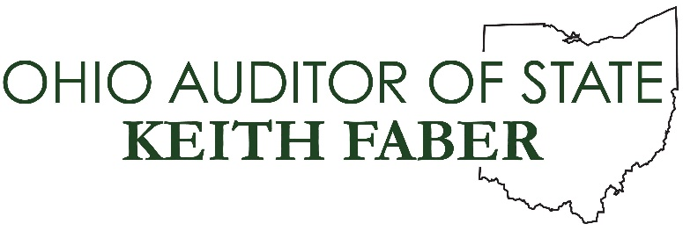

Senate Government Oversight and Reform Committee

Auditor of State Keith Faber

Senate Bill 10
March 5, 2019

Chairman Coley, Vice Chair Huffman, Ranking Member Craig, and members of the committee, thank you for allowing me to provide testimony today in support of Senate Bill 10.
There is no greater breach of the public trust than theft in office. When government officials steal from Ohio taxpayers, they must be held to the highest level of accountability. Unfortunately, current law prevents this from happening.
When theft in office occurs, my office is often the first to respond. These cases can be discovered during the course of our regular audit process or brought to our attention by concerned citizens. Our team of investigators evaluate every such accusation of fraud in government to root out corruption wherever it is found.
A theft in office conviction rightfully disqualifies the individual from ever holding any public office, public employment, or position of trust in Ohio again. However, under current law, the maximum charge and sentence for theft in office is a third degree felony, which carries up to 36 months in prison, regardless of the amount stolen. Theft convictions for non-public officials on the other hand, can rise to a first degree felony and result in up to 11 years in prison.

Since our office began tracking convictions in 2011, more than 85 former government officials have been charged with theft in office due, in part, to our audits and investigations.

In one case, the former utility clerk of the village of Ripley stole nearly $1 million dollars by using an “Adjusting Journal Entry Scheme” to accept utility payments, retroactively lower the customer’s balance in the system and then pocket the difference.

If a theft of the same amount was committed by a private citizen, that person could have been charged with a second degree felony. In the village of Ripley case, however, charges were capped at third degree felonies by the current law.

Why should a thief who steals $1 million receive a tougher penalty than a utility clerk who stole the same amount from taxpayers? Furthermore, why should taxpayers be on the hook for additional audit costs incurred during investigations of theft in office?

Senate Bill 10 solves both of these problems.
First, the bill would bring greater parity to the theft in office and theft statutes. Under the bill, theft in office of over $750,000 would carry an F-1 penalty, while theft in office of amounts between $150,000 and $750,000 would carry an F-2. These changes are completely appropriate for an individual holding a position of public trust.
Second, this legislation clarifies that judges must order forensic audit costs as restitution when the victim is a public entity. Currently, these costs are not considered a “direct and proximate result” of the theft.
SB 10 is a common sense solution that will hold corrupt public officials to a higher standard and ensure that taxpayers aren’t punished twice for someone else’s crime. I would like to thank Senator Wilson for his leadership on this issue and I am proud to support this legislation.
At this time, I would welcome any questions you may have. Thank you.

