SENATOR PEGGY LEHNER
6th District
SENATOR CECIL THOMAS
ASSISTANT MINORITY WHIP
9th District

Sponsor Testimony-SB 182
Senate Government Oversight and Reform Committee
September 17, 2019

Sen. Thomas:
Our legislation would raise the minimum age to purchase a firearm from 18 to 21 years old. Under current law, an individual must be 21 to buy a handgun; however, 18 year olds are able to purchase other firearms. This bill will maintain the current exemptions for law enforcement officers and active or reserve members of the armed services of the United States or the Ohio National Guard.
Increasing Ohio’s minimum age to purchase a firearm will help restrict young people’s access to these dangerous weapons, thereby decreasing the amount of suicides, homicides, and unintentional shootings among this population.
Our bill would make improperly furnishing a firearm to an underage person a felony of the third degree—an increase from the current fifth degree felony penalty. Individuals under 18 who attempt to purchase a firearm would be guilty of a delinquent act that would otherwise be a fourth degree felony if committed as an adult. If an individual is between ages 18 and 21, underage purchase of a firearm would be a second degree misdemeanor.
In 1968, federal law identified two categories of firearms: handguns and long guns. Handguns were the most common weapons used in gun crimes back then. As a result, handguns were regulated more strictly than rifles and shotguns.
But the times and technology has changed since 1968. Long guns are no longer just rifles used for hunting. We now have semi-automatic weapons that are considered long guns, something most likely inconceivable in 1968.
Federal law says that individuals must be 21 to purchase a handgun from a licensed dealer. In contrast, 18 year-olds can purchase long guns, including semiautomatic rifles. But if the seller is a private individual and unlicensed, those requirements melt away in states without comprehensive background checks: In these states, an 18-year-old can purchase a handgun, and there is no minimum age for who can buy a long gun.
Age requirements — and the gaps in federal law — entered the spotlight in February of last year, when a 19-year-old man used a legally purchased AR-15 rifle to murder 14 of his classmates and three school staffers in Parkland, Florida. Research shows that while most mass shootings involve handguns, long guns contribute to higher casualty counts.
Like most policies that restrict a segment of the population from owning guns, age restrictions garner stiff opposition from gun rights groups.
As a proud and longtime gun owner, I believe in the right of law-abiding citizens to own firearms. But I also believe that this right is one the government has both the authority and obligation to regulate in the interest of public safety. Increasing age requirements is an important strategy to consider.
Sen. Lehner:
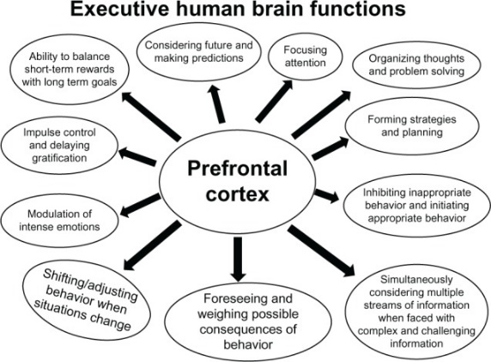
While an 18-year-old’s brain is similar to that of a fully mature adult, key cognitive processes continue to develop until approximately age 25. Adolescents tend to rely more heavily on the emotional regions of their brains, which can make it challenging for them to make logical and appropriate decisions. This is in part because the prefrontal cortex is one of the last regions to mature. The prefrontal cortex is the region of the brain that helps individuals exercise good judgement, cognitive analysis, abstract thought, and moderation of correct behavior in social situations. I have distributed a diagram that shows what functions the prefrontal cortex is responsible for regulating.
As you can see, some of these include: foreseeing and weighing possible consequences of behavior, impulse control, and the ability to balance short-term rewards with long term goals. These all can affect an individual’s ability to safely and appropriately use a gun. Adolescents tend to be less averse to risk than adults They can also be better motivated by reward than by negative reinforcement and as stated earlier, tend to motivated by short-term rather than long-term outcomes. This is problematic when looking at an adolescent owning or using a gun. It is clear that adolescents make more decisions out of emotion, simply because their brains are not fully developed. Decisions made out of emotion can turn deadly, especially when a gun is involved.
Owning a gun comes with a unique risk. While gun ownership improves the lives of some, irresponsible gun use can dramatically infringe upon the lives of others. We must bear in mind that not only do guns have the potential to cause harm to living creatures, they were designed for that purpose.
Consistent rules based on relative risk are necessary for efficient and effective policymaking. Not every person who drinks and drives will cause a crash, but laws nonetheless prohibit this behavior to limit the threat to public safety and potential for harm in the interest of a well-regulated society.
Of course, the effectiveness of minimum age laws is dependent upon a robust set of policies to identify and screen out individuals prohibited from gun ownership by age or criminal history; otherwise, like in our current system, people who intend to violate the law will be able to choose to purchase a gun from a private seller with no background check.
I recognize the need to implement evidence-based policies that do not infringe upon law-abiding citizens’ right to own guns. I believe by focusing on risk and accountability, we can create a policy environment in which those at greater risk for causing harm are prevented from accessing lethal means. Raising the legal age to purchase a semiautomatic rifle to 21 is a policy more states should consider if they want to reduce the toll of gun violence across America.

Arain, Mariam, et al.. Maturation of the adolescent brain. Neuropsychiatr Dis Treat. 2013; 9: 449–461. Published online 2013 Apr 3. doi: 10.2147/NDT.S39776
Barbalat, G, et al. “Risk-Taking in Adolescence: A Neuroeconomics Approach.” L'Encephale, U.S. National Library of Medicine, Apr. 2010, www.ncbi.nlm.nih.gov/pubmed/20434632.
Bjork, James. M, et al. Incentive-Elicited Brain Activation in Adolescents: Similarities and Differences from Young Adults. Journal of Neuroscience 25 February 2004, 24 (8) 1793-1802; DOI: 10.1523/JNEUROSCI.4862-03.2004

