My name is Ahmad Mostafavifar. I am a gun owner, Physician, Assistant Professor of Medicine at Ohio State University (OSU), and Board member at the Columbus Medical Association (CMA).

I believe that we can maintain the integrity of the Second Amendment, and at the same time make reasonable steps to make society safer. In doing so I’m providing written testimony in opposition of SB 237 Stand Your Ground Bill.

Most medical organizations are calling firearm deaths a public health emergency at a time when over a hundred Americans are dying every day from firearms. According to the Centers for Disease Control (CDC) there were almost 40,000 Americans killed from firearms in 2017, with about two thirds of these being suicides. Furthermore, according to the CDC, states with high gun ownership (WV, AL, WY, MS, LA) have a higher firearm mortality rate compared to states with low gun ownership (HI, MA, RI, NY, NJ).

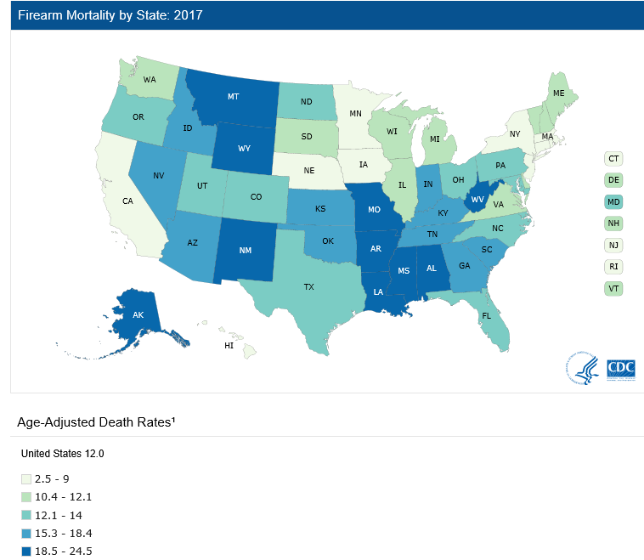

Globally, the United States (US) has the highest firearm death rate of developed countries (JAMA 2016). Firearm deaths are the second major cause of death in children and adolescents (Cunningham, NEJM 2018) behind only motor vehicle accidents, this is especially alarming as children have the most life years lost.

Firearms are lethal and intensify violence. When a perpetrator uses a gun rather than a knife or club or bare fists, the likelihood that the victim will die is greatly increased. The CDC breaks down firearm deaths into suicides, homicides, and gun accidents. In the US most firearms deaths are suicides in males, with the highest suicide death rate being in rural areas. Almost 65 Americans kill themselves with guns every day. Firearms in the home are associated with higher rates of suicide while, storing a gun loaded and unlocked are independent risk factors for suicide (Brent, Kellermann, Conwell). Furthermore, suicides are impulsive acts that are aided by the availability of a firearm. Red flags laws can allow family members or the police to remove firearms during this critical period. Removing guns will not eliminate all suicides. Some determined individuals will find ways to get guns or will choose alternative methods. But many others will not try at all. Simply put access to guns increases suicides.

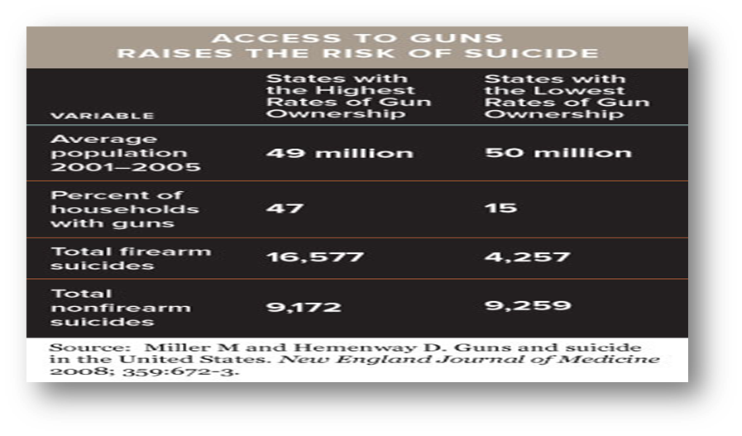
A comprehensive policy approach to reducing gun injuries includes sensible regulations concerning 4 time periods. The time of manufacture, time of sale, period of possession, and period of use. But most regulatory resources have gone into the last 2 time periods in the form of punishment or jail sentences. The U.S. already has the strictest jail sentences in the world and this has not deterred firearm related injuries and deaths. We need to look at the time of manufacture and sale of guns. Gun manufactures can make safer guns such as guns that don’t go off when dropped, magazine safeties, personalized guns, and etc. Gun distribution should require universal background checks, sale of firearms accompanied by educational programs in safe storage and use, raising the minimum age to purchase a firearm to twenty-one, and more support for The Bureau of Alcohol & Tobacco & Firearms & Explosives (ATF) to ensure gun dealers do not readily supply felons.

In particular, SB 237 would put children, families, and communities at risk by making Ohio a “Stand Your Ground” state. Stand Your Ground laws upend traditional self-defense laws, encouraging armed vigilantism and giving civilians in public places more leeway to shoot. Under current Ohio law, a person can use force, including deadly force, to defend himself anywhere. But when in public, a person cannot use force likely to kill or seriously injure someone if there is a safe way to avoid danger. This law would upend traditional self-defense law in Ohio and allow a person to shoot to kill in public, even when there is a clear and safe alternative. SB 237 is a very dangerous bill that will lead to more homicides in Ohio. The implementation of Florida’s stand your ground bill self-defense law was associated with a significant increase in homicides and homicides by firearm. In the majority of Florida’s stand your ground cases, the person who claimed stand your ground could have retreated to avoid the confrontation and the person killed in these disputes was unarmed. Furthermore, nearly 60% of those Floridians who claimed stand your ground had been arrested at least once before the day they killed someone. Not only are stand your ground laws dangerous but there are no studies that associate broadening self-defense laws with deterring crime.

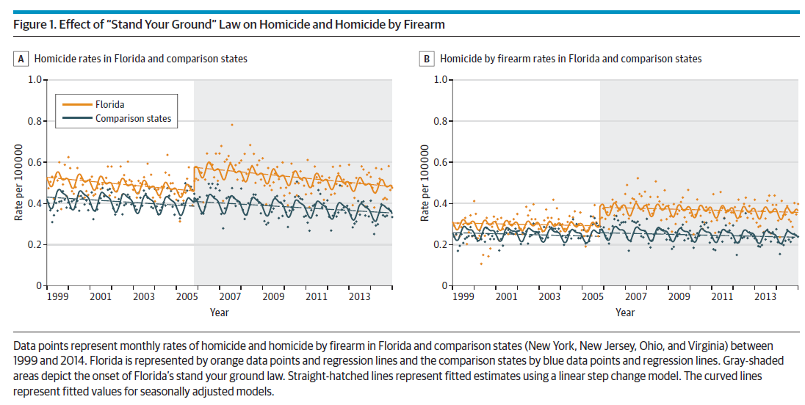

The American College of Physicians (ACP) has come out with a position paper on firearm deaths due to the continued public health crisis. Some of their recommendations include universal background checks, waiting periods, educational programs, and red flag laws.

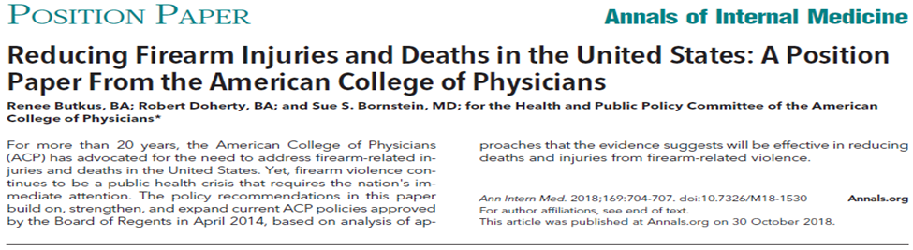

In conclusion, there is a way to keep society reasonably safe and maintain the integrity of the Second Amendment. We did it with cars by making them safer using air bags, anti-lock brakes, seat belts, driver’s license ages, child car seats, and manufacturing safer cars. We didn’t take cars away, we just made them safer and we can do the same with firearms. I urge your careful consideration of the many gun regulations being proposed and adopt new laws that make Ohio communities and your family safer. SB 237 is not one of them.

Opinions are my own.

Regards,
Ahmad Mehran Mostafavifar MD MBA
Assistant Professor of Medicine
Ohio State University College of Medicine
Board Member, Columbus Medical Association (CMA)
Chairman Drug Utilization and Review Committee, State of Ohio Medicaid

