Proponent Testimony for House Bill 11
November 13, 2019
Senate Health, Human Services and Medicaid Committee

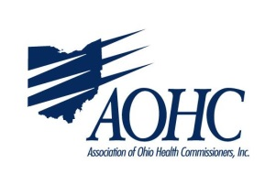

Chairman Burke and members of the Senate Health Committee, the Association of Ohio Health Commissioners (AOHC) is pleased to provide proponent testimony for House Bill 11.
As local health officials, we support any efforts to assist our citizens to quit smoking or not start in the first place. We also work within our community to assure comprehensive care for pregnant women – before, during and after their pregnancies – to provide for the best birth outcomes and reduce infant mortality.
HB 11 tackles both of these priorities, by authorizing Medicaid coverage for tobacco cessation interventions, including counselling and medications. There is probably no need to recount the cost savings related to tobacco cessation versus the cost of premature birth or the chronic illness that tobacco use can exacerbate. Paying for tobacco prevention and cessation will save money for the Medicaid program – that cannot be disputed, in addition to resulting in healthier births and extended life expectancy.
House Bill 11 also institutes additional education for families related to hazardous lead exposure. AOHC appreciates the legislature’s recognition that more can be done to address the longterm negative impact of high levels of lead in children.
Tobaccco use and lead exposure are longtime public health issues that local governmental public health has strived to address for many, many years! 2019 marks the 100th anniversary of the establishment of the local public health system in Ohio, and these problems have been prevalent for all of that time. Public Health is about prevention, the foundation of keeping our community members healthy– therefore, we are asking for your support of HB 11.

