I am concerned about the content of SCR10. In particular, I am concerned with the proposed OAC 3701-36-05 for the following reasons:

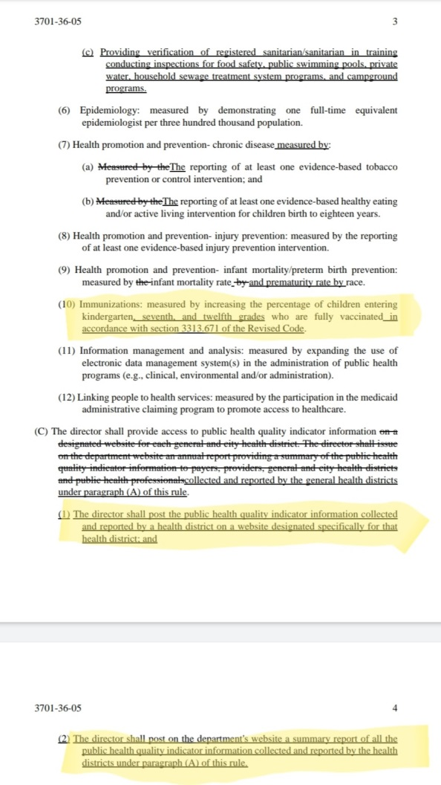

[http://www.registerofohio.state.oh.us/pdfs/3701/0/36/3701-36-05_PH_OF_A_RU_20180622_1633.pdf](https://urldefense.proofpoint.com/v2/url?u=https-3A__healthfreedomohio.org_EmailTracker_LinkTracker.ashx-3FlinkAndRecipientCode-3Dkyu6haIVQ-252fF-252f4uHmAy2mxg3F9z8goHm1DEk3gJB8LbZmnyV9qImBbpgx5S9Re948JV4P2vrq-252bWY3biWNnfLFY3QJDm-252funZgX3sjY3qRfHF0-253d&d=DwMFaQ&c=kRQx1TXm_68pneFHvOZEGQ&r=FlUn3vw_oczwcWQH7A8DqbZMzlCiZRJriuxf7S9JD9Y&m=H-RVCqwxZX9368wGw7vHHkII8AWdl2DEDNfgZ6Q5uf0&s=I3oQOp0c--3LumXxFAYeT-kyqlvIH5L0JXPxGNYp32Y&e=)

* Using money to punish county health departments whose citizens decline a pharmaceutical product is inappropriate and unethical.
* Government should not be using financial incentives to push a for-profit pharmaceutical product that is indemnified from liability.
* Public posting of vaccine product consumption rates does not reflect true immunization rates.

I understand that this proposed administrative rule went through the approval process and I regrettably was not aware of the language changes at that time. I respectfully request that you vote "No" on SCR10.

Sincerely,

Rachel Little  
3383 Willington Dr.  
Dublin, OH 43017  
614.746.2890