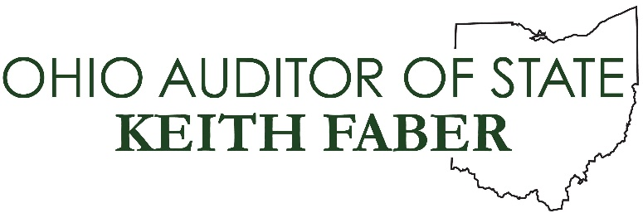

Senate Higher Education Committee

Auditor of State Keith Faber

Senate Bill 120
April 10, 2019

Chairwoman Kunze, Vice Chair Gavarone, Ranking Member Williams, and members of the committee - thank you for hearing my testimony today in support of Senate Bill 120. I would also like to thank Senators McColley and Rulli for their leadership on this legislation and recognition of the benefits performance audits provide to Ohio taxpayers.
Senate Bill 120 proposes a minor language change to state law that could result in major savings for state institutions of higher education and Ohio taxpayers by eliminating the cap on the number of higher education performance audits authorized each biennium. Performance audits provide objective, third-party analysis of the operations of state agencies, institutions of higher education, school districts, and local governments, helping them reduce costs, increase effectiveness, and make data-driven decisions. Unlike financial audits, which look backwards to ensure public monies were spent properly and that governmental bodies had appropriate internal controls in place, performance audits look forward to provide a roadmap for future savings and efficiencies.
For the purpose of this testimony, I will focus on the Auditor of State’s statutory requirement to conduct a minimum of four performance audits of state agencies per biennium - found in Ohio Revised Code §117.46. Since the implementation of this law in 2011, our office has completed 12 state agency performance audits, recommending nearly $110 million in potential savings, with an average return on investment of more than $27 for every dollar spent.
In 2017, the General Assembly amended the statute, authorizing our office to include one institution of higher education each biennium to fulfill the four performance audit minimum. The value of adding these institutions to the mix was realized through our performance audit of The Ohio State University.
Through a collaborative effort, AOS and university leadership agreed to an audit scope focused on the university’s use of computer servers, printers and copiers, and on the multiple systems used to hire and conduct background checks on employees.
This performance audit, with a very limited scope, yielded recommended savings of more than $6.4 million per year. OSU has already begun implementation of all recommendations, in full compliance with the statute.
The success of Ohio State’s performance audit has caused other institutions of higher education to seek their own similar review. However, with the cap under current law, it would take our office 74 years to conduct performance audits of Ohio’s 14 public universities and 23 community colleges.
Senate Bill 120 removes this cap with a simple language change that gives our office the authority to conduct performance audits on multiple institutions per biennium.
To be clear - our office is not shifting focus from state agencies - but rather adding to our performance audit capacity in order to find greater efficiencies and savings across state government in a shorter amount of time.
Senators McColley and Rulli summarized it best - the intent of this legislation is to allow institutions of higher education in our state to identify potential savings and make their organizations more efficient. A better, more efficient higher educational institution benefits the institution, its students and Ohio taxpayers.

Thank you again for allowing me to testify today, and I would welcome any questions you may have.

