WRITTEN TESTIMONY TO THE SENATE WAYS AND MEANTS COMMMITTEE

PROPONENT TESTIMONY
SB 190

NOVEMBER 5, 2019

Chair Roegner, Vice Chair Blessing, Ranking Member Williams, and members of the Senate Ways and Means Committee, thank you for the opportunity to write in support of SB 190, which would allow a law enforcement officer to claim a personal income tax credit of up to $500 for purchases of safety and protective gear.

We understand that in certain situations, law enforcement officers may want to enhance their municipal-issued equipment used in the line of duty. It is important that these officers are provided financial relief when trying to meet the requirements that they set for themselves.

Our first responders are the front lines in serving the residents and the businesses of our municipalities and play a vital role in the success of the state of Ohio. We support measures that support these vital members of our community.

Allowing local law enforcement officers to claim up to $500 annually in tax credit on their state income taxes is something we believe will be impactful to law enforcement officials across the State.

We appreciate that Sen. Schaffer has recognized the need for this tool allowing financial relief to first responders, and we urge your support of this bill.

Thank you for your consideration.

Sincerely,
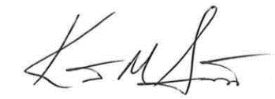

Kent Scarrett
Executive Director
Ohio Municipal League

